**TÜV Rheinland Vietnam continues to strengthen positioning in textile and garment industry with WRAP accreditation.**

**The Worldwide Responsible Accredited Production (WRAP) program is one of the world’s most recognized independent certification for the textile, apparel, garment, footwear and sewn products industry. The program monitors and certified lawful, humane and ethical production. Voluntary WRAP certification distinguishes manufacturers of all sizes aiming to successfully export products particularly to the United States.**

Having WRAP accreditation undoubtedly strengthen TÜV Rheinland Vietnam positioning in the Vietnam textile and garment industry specifically, and support Vietnam as one of the leading textiles exporting countries in general. “TÜV Rheinland Vietnam has built competency and trust in social compliance audit in the past few years. The recently obtained WRAP accreditation has complemented our social audit services portfolio, and we can now offer one stop solution to your audit needs.” said Mr. Juan Maties Garcia, Regional Business Field Manager of Customized Services of TÜV Rheinland for Asia Pacific & India Middle East and Africa (IMEA).

The foundation of WRAP principles is based on internationally accepted workplace standards, local laws, and workplace regulations. These encompass human resources management, health and safety, environmental practices, legal compliance, as well as import/export customs compliance and security standards.

Attaining WRAP certification sets your business apart as a dependable and trustworthy industry partner. Through our accredited auditing services, we assist you in enhancing your corporate image, boosting competitiveness, and ensuring successful import/export acceptance with WRAP certification. By aligning your goods with WRAP's ethical manufacturing standards of excellence, recognized by industry partners and consumers alike, you can also increase profits.

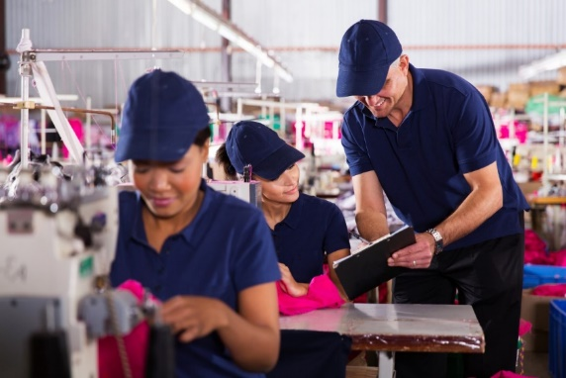

Having in-depth understanding of local labor, workplace safety, environmental laws, and regulation with high sensitivity to cultural and traditional differences, our accredited experts provide value added audit to your company for efficient and safe long-term solutions. TÜV Rheinland Vietnam is right partner of companies in textile and garment industry for independent audits to ensure that the facility fulfills requirements according to WRAP principles and achieve successful WRAP Certification.

***About TÜV Rheinland***

*TÜV Rheinland stands for safety and quality in virtually all areas of business and life. The company has been operating for more than 150 years and ranks among the world's leading testing service providers. It has more than 20,000 employees in over 50 countries and generates annual revenues of around 2.1 billion euros. TÜV Rheinland's highly qualified experts test technical systems and products around the world, support innovations in technology and business, train people in numerous professions and certify management systems according to international standards. In doing so, the independent experts generate trust in products as well as processes across global value-adding chains and the flow of commodities. Since 2006, TÜV Rheinland has been a member of the United Nations Global Compact to promote sustainability and combat corruption. Website:* [*www.tuv.com*](http://www.tuv.com/)

CONTACT:

TÜV Rheinland Media Contact:

Manager / Local Officer

Marketing and Communications

TÜV Rheinland Vietnam

Linh Duong (Ms.)

Tel: +84 28 3622 3081

Email: linh.duong@tuv.com