TÜV Rheinland: Partnership for Calibrated and Secure Charging Stations for E-cars

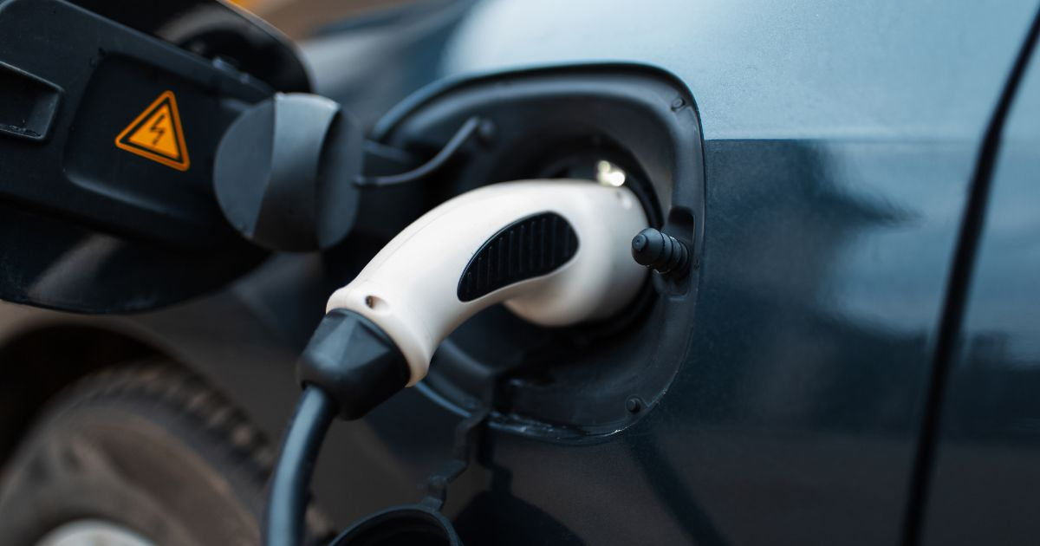

Sep 7, 2022 | Car, Traffic & Travel

Cooperation with Dutch company NMI / Complete package for implementing calibration law and the charging station ordinance / Technical safety and accurate billing are guaranteed / Numerous charging stations for e-cars are not yet calibrated in compliance with the law / [www.tuv.com/usa/en/electric-vehicle-charging-system-testing](http://www.tuv.com/usa/en/electric-vehicle-charging-system-testing)

Your contact for editorial questions:

**Press Office TÜV Rheinland**, Tel.: +49 2 21/8 06-21 48

You can also obtain the latest press releases as well as topic-related photos and videos by e-mail via presse@de.tuv.com and on the Internet: presse.tuv.com and www.twitter.com/tuvcom_presse

The number of publicly accessible charging stations for e-vehicles is growing steadily. However, a large proportion of the more than 65,000 charging points in Germany have not yet been calibrated. Those who use these charging points can therefore not rely on the fact that only the amount of electricity that has actually been charged is calculated. The partnership now agreed between TÜV Rheinland and the Dutch company NMI will create reliable conditions for this in the future. “By cooperating with NMI, we can offer operators of charging stations a complete testing service,” says Roman Brück, Team Leader Power Electronic at TÜV Rheinland. “NMI is one of the leading independent specialists for legally compliant testing and inspection services in measurement technology. As two companies that both have the same testing and quality requirements, we can thus make an important contribution to the calibration law compliance of charging columns both in Germany and globally.”

**Secure charging stations and correct billing**  
The fact that charging stations are subject to calibration law has been a legal requirement in Germany since April 2020. Among other things, this includes informing customers via the charging station’s display how much electrical energy they are drawing, how long the charging process takes, and how much a kilowatt hour (kWh) costs. The overall package of the partnership between the NMI and TÜV Rheinland also includes all the tests required by the charging station ordinance.

In addition to testing for electromagnetic compatibility (EMC), the “one step testing” for operators also includes all safety tests right up to the grid connection. This prevents faulty charging stations from causing grid overloads, equipment and system failures, and endangering people. “Violations of the calibration law and the charging station ordinance can be punished with a fine of up to 50,000 euros. However, in order to achieve the desired rapid expansion of the charging infrastructure, the authorities have so far refrained from imposing sanctions on operators of non-calibrated charging stations,” explains TÜV Rheinland expert Roman Brück.

150 years of safety: Since 1872, TÜV Rheinland’s mission has been to make technology safe for people and the environment. From the steam engine to digitalization, the erstwhile “Verein zur Überwachung der Dampfkessel in den Kreisen Elberfeld und Barmen” (Association for the Inspection of Steam Boilers in the Districts of Elberfeld and Barmen) has evolved into a global testing service provider ensuring safety and quality in virtually all areas of business and life. This responsibility is now shared by more than 20,000 employees, who generate annual revenues of around EUR 2.1 billion. Around the globe, experts from TÜV Rheinland test technical systems and products, support innovations in technology and industry, train personnel in a wide range of professions, and certify management systems according to international standards. With safety and sustainability, TÜV Rheinland is also shaping the future. Since 2006, TÜV Rheinland has therefore been a member of the United Nations Global Compact to promote sustainability and combat corruption. Website: [www.tuv.com](https://www.tuv.com/)