TÜV Rheinland: Extended testing standard for the photovoltaic industry

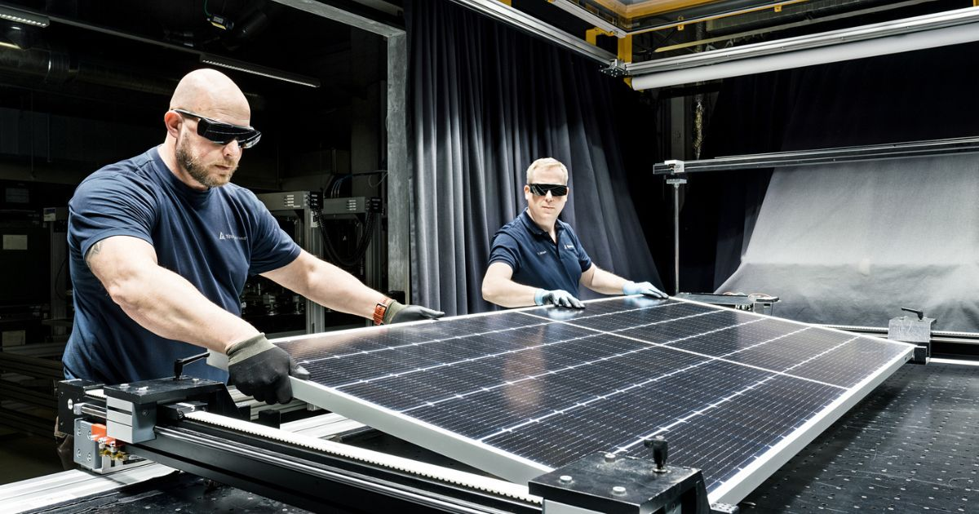

Oct 25, 2022 | Industry & Digitalization

Quality assurance for solar simulators / Important aspects added / Additional requirements beyond the 2020 International Electrotechnical Commission (IEC) standard / [www.tuv.com/solar](https://www.tuv.com/solar)

Your contact for editorial questions:

**Press Office TÜV Rheinland**, Tel.: +49 2 21/8 06-21 48

You can also obtain the latest press releases as well as topic-related photos and videos by e-mail via presse@de.tuv.com and on the Internet: presse.tuv.com and www.twitter.com/tuvcom_presse

TÜV Rheinland offers its own test standard for solar simulators for the photovoltaic industry. Manufacturers of turnkey solar simulator systems will thus receive an extended service to confirm their product quality. This involves the highly accurate performance measurement of PV modules or solar cells as well as the user- and maintenance-friendliness of their systems.

The newly developed TÜV Rheinland standard is based on the standard of the International Electrotechnical Commission (IEC) 60904-9:2020, which has been comprehensively revised in 2020. However, the new standard goes far beyond the international standards by additionally taking into account important aspects of quality assurance. Among other things, the experts of TÜV Rheinland scrutinize the variation in technical performance between different systems of the same type and analyze the possible effects of lamp changes. In addition, special effects that may occur during the specified service life time of the lamps are closely monitored by the experts. The neutrality of environmental influences at the respective installation site is also a component of this extended test, as is the existence of a calibration management system and an appropriate calibration service. The extended scope of the certification also includes a review of technical documentation, training measures, troubleshooting instructions, and service and maintenance instructions.

**Certification for solar simulator manufacturers**

In addition to classification tests for module manufacturers, experts or testing and research institutes, the testing service provider now also offers certification for solar simulator manufacturers and their products. The requirements for this certification were recently changed to the new TÜV Rheinland standard “2 PfG 2788/12.21” (“Classification of turn-key solar simulator systems for PV module and solar cell measurements”). The first sun simulator system certified according to the new TÜV Rheinland standard 2 PfG 2788/12.21 is the MBJ Sun Simulator 4.0, including the WIDE/ECO/MAX variants, from Ahrensburg-based manufacturer MBJ Solutions GmbH.

For more information, visit <https://www.certipedia.com/quality_marks/1111257143?locale=en> at TÜV Rheinland.

150 years of safety: Since 1872, TÜV Rheinland’s mission has been to make technology safe for people and the environment. From the steam engine to digitalization, the erstwhile “Verein zur Überwachung der Dampfkessel in den Kreisen Elberfeld und Barmen” (Association for the Inspection of Steam Boilers in the Districts of Elberfeld and Barmen) has evolved into a global testing service provider ensuring safety and quality in virtually all areas of business and life. This responsibility is now shared by more than 20,000 employees, who generate annual revenues of around EUR 2.1 billion. Around the globe, experts from TÜV Rheinland test technical systems and products, support innovations in technology and industry, train personnel in a wide range of professions, and certify management systems according to international standards. With safety and sustainability, TÜV Rheinland is also shaping the future. Since 2006, TÜV Rheinland has therefore been a member of the United Nations Global Compact to promote sustainability and combat corruption. Website: [www.tuv.com](https://www.tuv.com/)