TÜV Rheinland: Allergy Care Certification for Better Air Quality

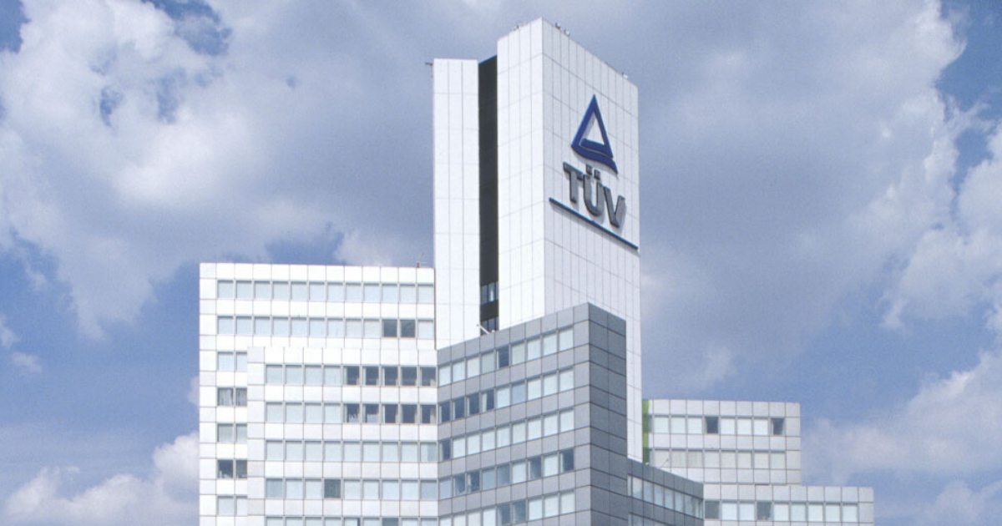

Sep 6, 2022 | Education & Health

Fewer allergy risks and cleaner, healthier indoor climate thanks to certified air filters / TÜV Rheinland develops standard / Models from Xiaomi certified.

Your contact for editorial questions:

**Press Office TÜV Rheinland**, Tel.: +49 2 21/8 06-21 48

You can also obtain the latest press releases as well as topic-related photos and videos by e-mail via presse@de.tuv.com and on the Internet: presse.tuv.com and www.twitter.com/tuvcom_presse

With a new standard developed in-house, TÜV Rheinland is helping manufacturers of household products reduce allergy risks and contribute to a clean, healthy indoor climate. The Allergy-Care certificate is aimed at manufacturers of products such as robotic sweepers, air conditioners, air purifiers, vacuum cleaners and washing machines. For example, four air purifiers from the manufacturer Xiaomi Smart Air Purifier 4-Series recently received Allergy-Care certification from TÜV Rheinland.

Products with an Allergy Care certificate from TÜV Rheinland clean the air of common indoor allergens such as pollen, dust mites and animal hair. In this way, they effectively eliminate potential health hazards indoors. Background: For allergy sufferers, even the smallest amounts of allergenic particles in indoor air can trigger adverse health effects. For this reason, TÜV Rheinland tests whether a product effectively eliminates allergens in accordance with the standard it developed itself, “2 PfG 2753/02.21”. For the Allergy Care certificate, air filters must achieve an efficiency of 95 to 99.999995 percent.

**Neutralization of odors**

Another component of the Allergy Care certification by TÜV Rheinland is the neutralization of odors. Not only are odors unpleasant for allergy sufferers, they can also indicate a more serious household hygiene problem. Effective elimination of odors is therefore an important feature of air filters.

TÜV Rheinland's Allergy Care certification helps manufacturers standardize product design and consumers select high-quality allergen filtration products. In the future, TÜV Rheinland intends to work with more manufacturers to conduct research, develop standards in related areas, and promote the general level of technology in improving the situation for allergy sufferers.

150 years of safety: Since 1872, TÜV Rheinland’s mission has been to make technology safe for people and the environment. From the steam engine to digitalization, the erstwhile “Verein zur Überwachung der Dampfkessel in den Kreisen Elberfeld und Barmen” (Association for the Inspection of Steam Boilers in the Districts of Elberfeld and Barmen) has evolved into a global testing service provider ensuring safety and quality in virtually all areas of business and life. This responsibility is now shared by more than 20,000 employees, who generate annual revenues of around EUR 2.1 billion. Around the globe, experts from TÜV Rheinland test technical systems and products, support innovations in technology and industry, train personnel in a wide range of professions, and certify management systems according to international standards. With safety and sustainability, TÜV Rheinland is also shaping the future. Since 2006, TÜV Rheinland has therefore been a member of the United Nations Global Compact to promote sustainability and combat corruption. Website: [www.tuv.com](https://www.tuv.com/)