Offshore wind: TÜV Rheinland wins testing contract from Vestas

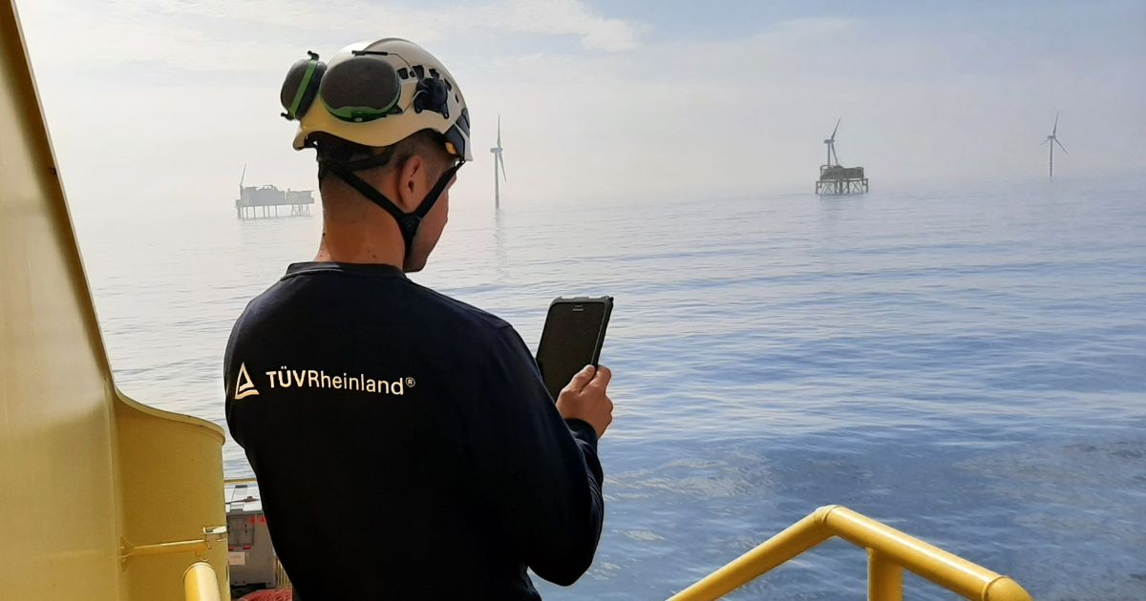

Nov 25, 2022 | Industry & Digitalization

Testing of wind turbines before commissioning with innovative concept / 27 turbines for wind farm in the Baltic Sea / TÜV Rheinland continues to expand its offering in the renewable energies sector

Your contact for editorial questions:

**Press Office TÜV Rheinland**, Tel.: +49 2 21/8 06-21 48

You can also obtain the latest press releases as well as topic-related photos and videos by e-mail via presse@de.tuv.com and on the Internet: presse.tuv.com and www.twitter.com/tuvcom_presse

TÜV Rheinland has won a major contract to test offshore wind turbines from Danish manufacturer Vestas. Under the contract, TÜV Rheinland experts will test lifts, cranes, pressure vessels and safety-related components of 27 of the company's wind turbines. The tests will be carried out prior to commissioning of the turbines, which are scheduled to start operation in 2023 in the Baltic Sea as the “Arcadis Ost 1” wind farm with an installed capacity of 257 megawatts. The Danish wind turbine manufacturer Vestas is one of the world's most renowned manufacturers in the offshore wind energy market. The company has installed more than 160 gigawatt (GW) of wind power capacity.

TÜV Rheinland developed an innovative concept for the contract. The aim was to cover all inspection requirements while reducing costs and risks. For example, TÜV Rheinland’s experts test numerous components of the plants while they are still in port. This eliminates many of the costly tests on the high seas and the final offshore test could be reduced to a minimum.

“Offshore wind makes a significant contribution to the shift toward renewable energies. With our comprehensive testing expertise, we are helping to ensure that the wind energy industry can meet these expectations and achieve its ambitious growth targets safely and reliably,” says Lars Mitzka, Team Leader Offshore Wind at TÜV Rheinland. For TÜV Rheinland, the offshore wind business is an important pillar of the wind energy business. According to business field manager Sebastian Rothe it is to be further expanded in the coming years.

150 years of safety: Since 1872, TÜV Rheinland’s mission has been to make technology safe for people and the environment. From the steam engine to digitalization, the erstwhile “Verein zur Überwachung der Dampfkessel in den Kreisen Elberfeld und Barmen” (Association for the Inspection of Steam Boilers in the Districts of Elberfeld and Barmen) has evolved into a global testing service provider ensuring safety and quality in virtually all areas of business and life. This responsibility is now shared by more than 20,000 employees, who generate annual revenues of around EUR 2.1 billion. Around the globe, experts from TÜV Rheinland test technical systems and products, support innovations in technology and industry, train personnel in a wide range of professions, and certify management systems according to international standards. With safety and sustainability, TÜV Rheinland is also shaping the future. Since 2006, TÜV Rheinland has therefore been a member of the United Nations Global Compact to promote sustainability and combat corruption. Website: [www.tuv.com](https://www.tuv.com/)