TÜV Rheinland: First Notified Body for New Omani Conformity Scheme

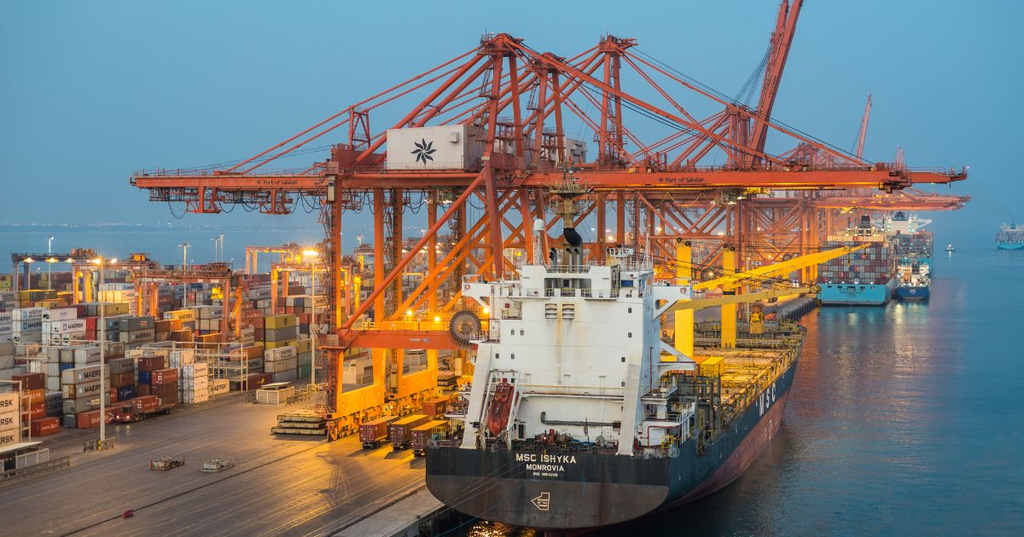

Aug 12, 2022 | Consumers & Product Safety, Industry & Digitalization

Omani Type Examination certificates for manufacturers and importers of regulated products / Stage 1 covers dishwashers, washing machines, and vacuum cleaners

Your contact for editorial questions:

**Press Office TÜV Rheinland**, Tel.: +49 2 21/8 06-21 48

You can also obtain the latest press releases as well as topic-related photos and videos by e-mail via presse@de.tuv.com and on the Internet: presse.tuv.com and www.twitter.com/tuvcom_presse

TÜV Rheinland has been designated as the first Notified Body for the new Omani Conformity Scheme. Starting immediately, TÜV Rheinland can provide Omani Type Examination certificates to manufacturers and importers of regulated products.

The designation was granted by the Directorate General for Specifications and Measurements (DGSM) of the Sultanate of Oman. The DGSM, as a directorate under the Ministry of Commerce, Industry and Investment Promotion (MoCIIP) of the Sultanate of Oman, is implementing the technical regulations for the new Omani Conformity Scheme, which came into force June 5, 2022. Products subject to these regulations need to obtain certification from a Notified Body designated by the DGSM. Conformity certificates are valid for one year and subject to annual renewal.

Regulated products in Stage 1 cover dishwashers, washing machines, and vacuum cleaners. Manufacturers are required to apply for the Omani Type Examination certificate from a Notified Body. These products must undergo safety and EMC tests, and the manufacturer has to prepare product design and risk analysis documentation.

**Raising product quality in the market**

According to UN Comtrade, in 2021 Oman imported US$26.2 million in dishwashers, US$13 million in washing machines, and US$2 million in vacuum cleaners. The implementation of the Omani Conformity Scheme raises the product quality in the market. Stages 2 and 3 of the Omani Conformity Scheme are expected in 2023 and 2024, and non-electrical products may be included in the scheme.

TÜV Rheinland is also a designated certification body for the Gulf G-mark, Oman and Bahrain energy efficiency, UAE ECAS & EQM, Saudi SALEEM, Kuwait KUCAS, and can provide complete market access solutions for the Middle East market (Saudi Arabia, Iraq, Kuwait, the UAE, Oman, Bahrain, Qatar, Yemen).

150 years of safety: Since 1872, TÜV Rheinland’s mission has been to make technology safe for people and the environment. From the steam engine to digitalization, the erstwhile “Verein zur Überwachung der Dampfkessel in den Kreisen Elberfeld und Barmen” (Association for the Inspection of Steam Boilers in the Districts of Elberfeld and Barmen) has evolved into a global testing service provider ensuring safety and quality in virtually all areas of business and life. This responsibility is now shared by more than 20,000 employees, who generate annual revenues of around EUR 2.1 billion. Around the globe, experts from TÜV Rheinland test technical systems and products, support innovations in technology and industry, train personnel in a wide range of professions, and certify management systems according to international standards. With safety and sustainability, TÜV Rheinland is also shaping the future. Since 2006, TÜV Rheinland has therefore been a member of the United Nations Global Compact to promote sustainability and combat corruption. Website: [www.tuv.com](https://www.tuv.com/)