English version for English website.
TÜV Rheinland Japan Issues ISO/IEC 42001 Certification to NTT DATA Group Corporation
November 27, 2025
TÜV Rheinland Japan announced today that it has issued ISO/IEC 42001 certification to NTT DATA Group Corporation and NTT DATA Japan. This marks the first ISO/IEC 42001 certification issued by TÜV Rheinland Japan.
Certified Organizations:
- NTT DATA Group Corporation
- NTT DATA Japan
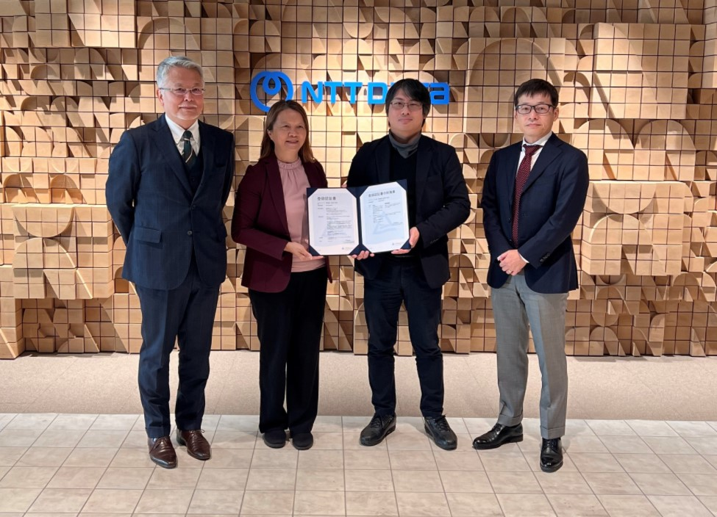

Scope of Certification:
Development and provision of the generative AI solution “LITRON Generative Assistant.”
ISO/IEC 42001 is an international standard that provides comprehensive support for establishing, implementing, maintaining, and improving AI management systems. As AI technology rapidly advances and becomes integrated into society, this standard serves as a critical guideline for ensuring reliability, transparency, and ethical practices in AI development and operations. By obtaining ISO/IEC 42001 certification, NTT DATA demonstrates compliance with global standards, further strengthening trust among stakeholders.
Comment from NTT DATA Group Corporation:
Kyōhei Fushida, Ph.D. Head of Technology Governance Unit. Global Governance Headquarters, stated:
“NTT DATA Group Corporation and NTT DATA Japan have been working to build AI governance aimed at creating value through fair and sound AI utilization and contributing to sustainable societal development. For our generative AI solution, LITRON Generative Assistant, we have continuously pursued organizational improvements to deliver highly reliable AI solutions. Our efforts to create an environment where customers can confidently use generative AI have been recognized, leading to certification for the development and provision of LITRON Generative Assistant. We will continue striving to provide trusted AI systems and expand the scope of ISO/IEC 42001 certification as part of our ongoing AI governance activities.”
Comment from TÜV Rheinland Japan:
Takashi Kamakari, General Manager of Management System Certification, People & Business Assurance, said:
“We are delighted to award our first ISO/IEC 42001 certification to NTT DATA. This achievement will further enhance trust in NTT DATA as it leverages cutting-edge technologies to address diverse challenges.”
Benefits of ISO/IEC 42001 Certification:
- Enhanced Reliability: Demonstrates compliance with international standards for AI design, development, and operation, earning trust from customers, partners, and society.
- Strengthened Risk Management: Establishes a framework for managing ethical, legal, and technical risks related to AI, improving business stability.
- Transparency and Accountability: Increases transparency in AI decision-making processes and operational policies, enabling accountability to stakeholders.
- Competitive Advantage: Builds an AI management system aligned with global standards, differentiating in domestic and international markets.
- Regulatory and Social Compliance: Responds to growing regulations and societal expectations, showcasing responsible AI practices.
TÜV Rheinland Japan will continue promoting ISO/IEC 42001 certification and supporting the healthy development and social acceptance of AI technologies.
About NTT DATA Group Corporation:
NTT DATA Group Corporation aims to create a prosperous and harmonious society by providing IT services in over 50 countries worldwide. We work with clients to address social challenges and drive business transformation through digital technologies, offering services from consulting to system development and operations.
Website: https://www.nttdata.com/global/ja/

