Safety
Manufacturers, traders must ensure that their products comply with relevant technical requirements and marketed products are safe.

Aim of Certification
The aim of certifying products is to give confidence to all interested parties that a product fulfils specified requirements.

Certification Scheme
The Product Certification Body issues the Certificate of Conformity based on the “Product Conformity Certification Scheme of TÜV Rheinland InterCert Kft. (MS-0040109)”. The certificate attests that the product is in conformity with the applied standards.
The Certificate Holder is entitled to use the certificate as a basis to declare the conformity of certified product. The certificate does not imply assessment of the series-production of the product and does not permit the use of a TÜV Rheinland mark of conformity.
The competence of Product Certification Body is proven based on the accreditation by the Hungarian National Accreditation Authority (NAH).

Certification process
The certification is conducted through the below process steps and with conformity assessment methods:
Application (providing product data
Quotation
Order
(contract)
Evaluation (testing/
inspection)
Certification

- Any party interested in designing, manufacturing/developing, marketing of a product can apply for the certification. As a first step, the description of the product (e.g. intended use, functions) as well as its ratings and classifications need to be provided, and if any report has been already issued by an impartial and accredited testing laboratory or inspection body.
- Based on this information, we check if the product can be certified under the scheme and determine the applicable requirements and conditions for certification. After the review of application, we prepare our quotation for evaluation, review and certification, that includes the requirements and conditions.
- After the client accept the conditions in our quotation, we conclude the contract.
- In case of electrical, electronic, and mechanical products, the evaluation (type test) of the product is performed in the accredited testing laboratory of TÜV Rheinland InterCert Kft. according to the applicable requirements. The testing laboratory is accredited by the Hungarian National Accreditation Authority (NAH).
In case of software programs and software tools, the evaluation (inspection) is performed by the accredited inspection body of TÜV Rheinland Industrie Service GmbH according to the applicable requirements. The inspection body is accredited by the Deutsche Akkreditierungsstelle (DAkkS).
Alternatively, a test/inspection report, in Hungarian or English language, issued by an impartial testing laboratory/inspection body possessing an internationally recognized accreditation (ILAC, EA) may be accepted.
- After that, we review the documentation of evaluation and in case of a positive result, we issue the Certificate of Conformity. The validity of certificates can be verified in our publicly available database, Certipedia.

Requirements
The evaluation and certification are performed according to Hungarian national, European or international standards applicable to the product, which fall within the scope of the scheme. These standards are listed within the List of Standards of the Product Certification Body per product categories (list identification: SZ D). The actual standard list is available on our website under the Downloads menu.
The further certification related requirements are determined in the Product Testing, Inspection and Certification Regulation of TÜV Rheinland InterCert Kft., available on our website.

Scope of Certification
The scope of the certification scheme applies the following product categories. The products are listed under the categories, detailed in the standard list (SZ D).

Wires, cables, insulation materials
Installation materials, connectors
Switches, controllers, regulators
Protective devices against electrical hazards
Electrical appliances for household and similar use
Transformers
Vehicles
Power tools
Machineries
Playground equipment and toys
Mechanical devices
Lighting devices
Capacitors
Accumulators, batteries
Electromagnetic compatibility (EMC)
Electromagnetic field(EMF)
Medical devices
Electronic devices
Road vehicles and components

Sample of Certificate of Conformity

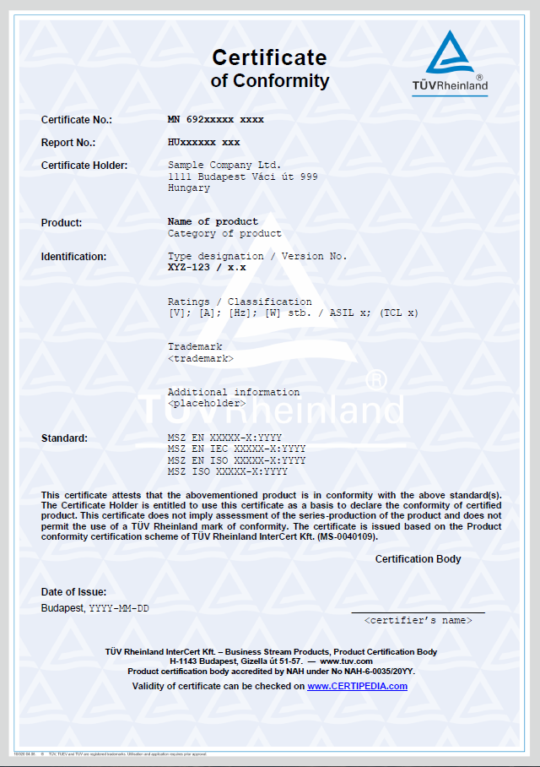

TÜV Rheinland InterCert Kft. – Business Stream Products, Product Certification Body
H-1143 Budapest, Gizella út 51-57. ― www.tuv.com

